Why we need to run Jenkins on Tomcat why not on standalone system of Jenkins (jetty)?

* We can start all the application in single server.
* We also can deploy Jenkins on other containers like

1. Glassfish
2. Jboss
3. IBM WebSphere
4. Jetty
5. Jonas and etc.

* As of now we are using tomcat.
* For Jenkins we need to have “tomcat 8” and jdk version>7.
* For downloading tomcat use the link

<https://tomcat.apache.org/download-80.cgi>

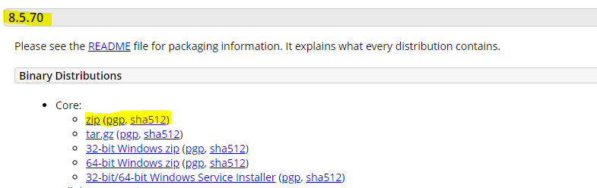

* *NOTE: [For downloading the jdk(version 11) go through the other document.]*
* Then once the zip file is downloaded extract the file and place where ever you need in the system.[usually place on Desktop]
* Then once you have extracted now go to the “Jenkins” folder in where you have installed.
* And **copy** the **Jenkins.war** file and place it inside the “**webapps**” folder of Tomcat extracted folder.

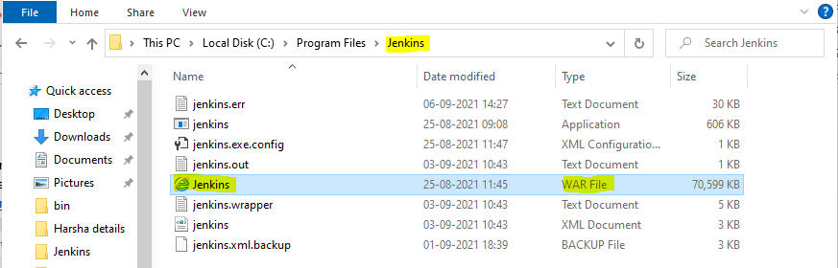

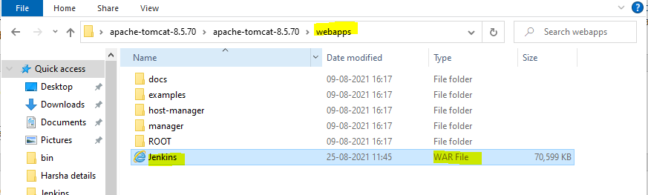

* Once these things are set now go to command prompt.
* And change the directory to the bin directory of Tomcat.
* In my case:

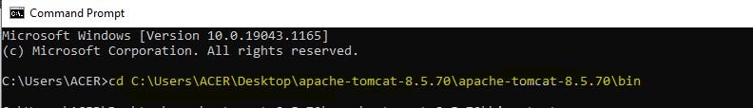

* Then type the command startup
* The startup is actually a .sh extensioned file name, which will start the Tomcat application.
* Once this is typed another cmd of tomcat will be opened and that looks as:

